## Automatic Water Tap controller

prepared by s

Md Ashiqur Rahman ( 1405024)

Md Sadiqur Rahman ( 1405030)

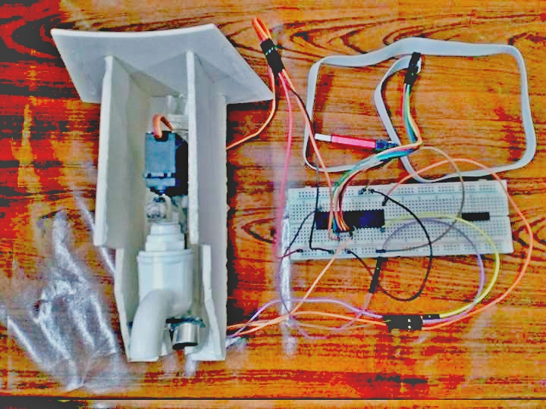

## Table of Contents

* Introduction
* Hardware Requirements
* Software Requirement
* Flowchart
* Block Diagram
* Circuit Diagram
* Description of Modules
* Challenges Faced
* Acknowledgment

## Introduction

This project aims to reduce the loss of water in daily life while using water taps as well as bring automation our life. Our system will automatically open the water tap by sensing the presence of object below the tap. For sensing the presence of object we have used sonar sensor. And to open the water tap we have used servo motor. Our system automatically close the tap when the object is removed . Thus it will make our life a lot easier and also reduce water loss.

[Project vedio](https://www.youtube.com/watch?v=YzjFS5HeYNQ&feature=youtu.be)

## Hardware Requirement

List of equipments used is listed below:

|  |  |
| --- | --- |
| Equipment ( number) | Cost |
| Atmega32 Microcontroller (1) | 600 |
| Sonar Sensor HC-SR04 (1) | 110 |
| Servo motor FS51(1) | 1000 |
| Water tap(1) | 100 |
| Bread board, wires etc | 200 |

## Software Requirement

● ATmel Studio 7 (to compile .c code and build .hex and .eep file)

● eXtreme Burner - AVR (to load .hex and .eep file onto ATmega32)

● Proteus 8 Professional (for circuit design)

## Flowchart



## Block Diagram

## 

## Circuit Diagram

## 

## Actual Circuit

## 

## Description of Modules and Sensors

**Ultrasonic Module HC-SR04:**

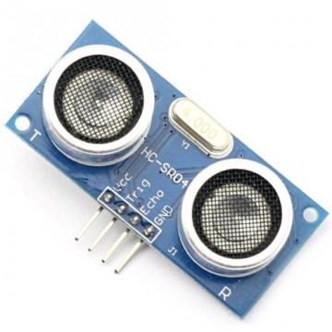Ultrasonic Module HC-SR04 works on the principle of SONAR and RADAR system.

* HC-SR-04 module has ultrasonic transmitter, receiver and control circuit on a single board.
* The module has only 4 pins, Vcc, Gnd, Trig and Echo.
* When a pulse of 10µsec or more is given to the Trig pin, 8 pulses of 40 kHZ are generated. After this the Echo pin is made high by the control circuit in the module.
* Echo pin remains high till it gets echo signal of the transmitted pulses back.
* The time for which the echo pin remains high, i.e. the width of the Echo pin gives the time taken for generated ultrasonic sound to travel towards the object and return.
* Using this time and the speed of sound in air, we can find the distance of the object using simple formula for distance using speed and time.

For more information about ultrasonic module HC-SR04 [Ultrasonic Module HC-SR04](http://www.electronicwings.com/sensors-modules/ultrasonic-module-hc-sr04) .

Time calculation

When the rising edge capture occurs at Echo pin which is connected to an input of ATmega16, start Timer of ATmega16 and again wait for falling edge on Echo pin.

As soon as the falling edge is captured at the Echo pin, microcontroller read the count of the Timer. This time count is used to calculate the distance to an object.

we have used [input capture mode of Atmega16](http://www.electronicwings.com/avr-atmega/atmega1632-timer-input-capture-mode) on PD6(ICP1) pin as shown in circuit diagram.

**Calculation (distance in cm)**

Sound velocity = 343.00 m/s = 34300 cm/s

Distance of Object (in cm) = sound velocity * TIMER VALUE/2

=17150* TIMER

Now, here we have selected internal 8 MHz oscillator frequency for ATmega16, with No prescaler for timer frequency. Then time to execute 1 instruction is 0.125 us.

So, timer gets incremented after 0.125 us time elapse.

= 17150 x (TIMER value) x 0.125 x 10-6cm

= 0.125 x (TIMER value)/58.30cm

= (TIMER value) / 466.47 cm

Servo motor FS51

Specifications

• Weight: 50 g

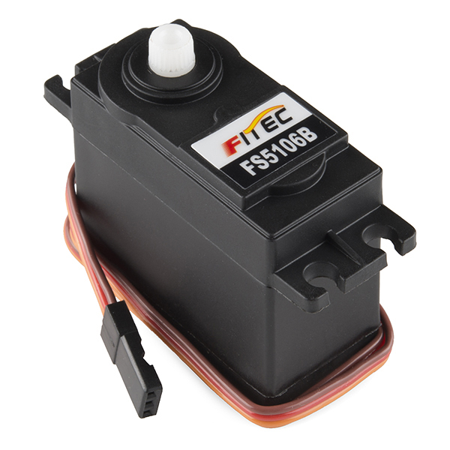• Dimension: 22.2 x 11.8 x 31 mm approx.

• Stall torque: 9 kgf·cm

• Operating voltage: 5-7 V

• Dead band width: 10 µs

• Temperature range: 0 ºC – 55 ºC

Working procedure :

Motor rotates a particular angle depending on the duration of the signal it is provided to the control pin . The data sheet is available in here [DATASHEET](https://www.google.com/url?sa=t&rct=j&q=&esrc=s&source=web&cd=1&cad=rja&uact=8&ved=0ahUKEwiXj-bp2enYAhWKo48KHQGYAAsQFggnMAA&url=http%3A%2F%2Fwww.ee.ic.ac.uk%2Fpcheung%2Fteaching%2FDE1_EE%2Fstores%2Fsg90_datasheet.pdf&usg=AOvVaw0mGSoDobEfBgrMGA5MSSwn).

We have connected control pin of the motor to PC6 . And provided with external voltage in the VCC pin

## Problems we faced

Our microcontroller was partially malfunctioned. As a result we have wasted a huge amount of time debuging a partially malfunctioned component.

Motors are very sensitive toward input voltage . Voltage from Atmega32 was not enough to attain the full power of motor. External power must be used for motor.

Rotation of motor angle is not accurate to the point . The structure must be able withstand little excess rotational force.

## Acknowledgment

The new e-commerce site “Gyangam” is supplying different electronic components inside the campus without any cost any time . This is own by few BUET students of 15 batch.

The site [CircuitDigest](https://www.google.com/url?sa=t&rct=j&q=&esrc=s&source=web&cd=1&cad=rja&uact=8&ved=0ahUKEwiSsujr3-nYAhUFtI8KHZTTBE4QFggqMAA&url=https%3A%2F%2Fcircuitdigest.com%2Fmicrocontroller-projects%2Fdistance-measurement-using-hc-sr04-avr&usg=AOvVaw358ywae-Ng5lvHijxCoG_I) is of great use in our project .